Feedback Form About Classes Art Of Parenting!
Thank you for your participation today! Copy/paste this form and after filling it out, please email it to info@ArtOfParenting.info

Name:

What is one thing (insight) you have learned from the class today?

What do you need or want to learn more of?

What will you have difficulty applying?

What tool will you use this week?

What is in the way of using and implementing the tips, skills or tools learned in this class?

What is your overall feeling about the class today?

Do you have comments for the facilitator(s) so they can improve delivering this class?

Thank you for taking the time to fill this out,
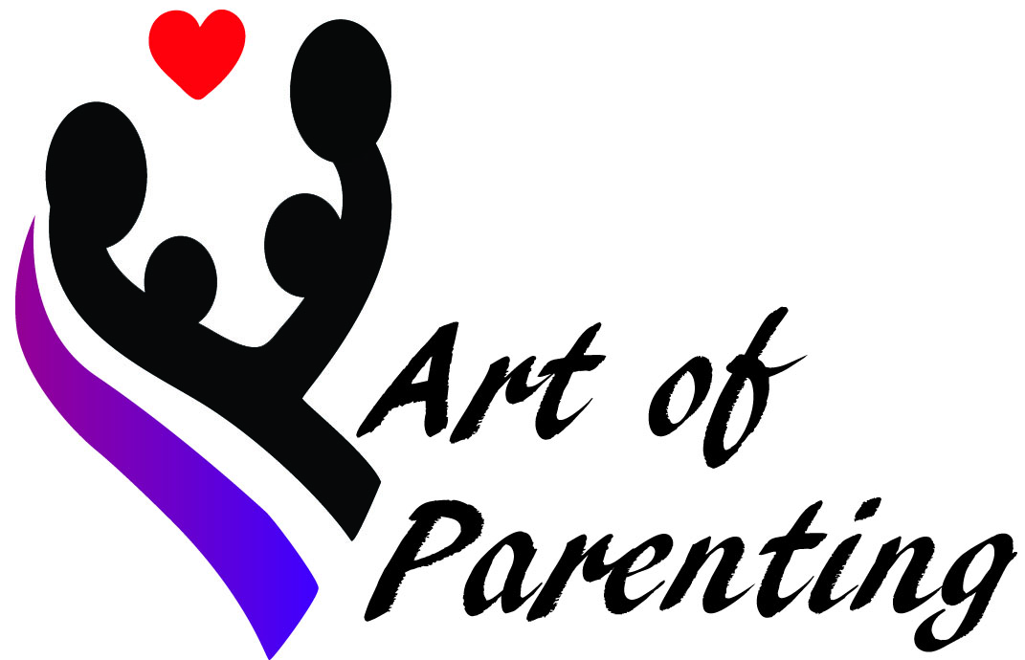
Martina

