Art Of Parenting Course Class Preparation Form:
Please send 24 hours before you the next class to info@ArtOfParenting.info

Please answer the questions below.

As a parent, what were your greatest challenges this past week?

What are the issues that have come up?

What tools did you learn in the last class that were helpful? What was the result?

What specific action steps have you taken this week?

What did you intend to do or commit to doing but didn’t do?

What got in the way?

What has happened since our last class that you feel really good about?
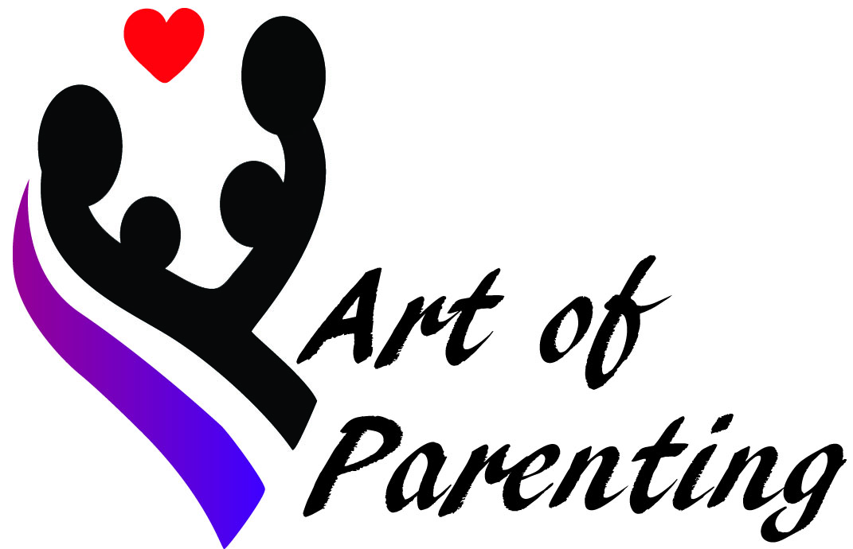

What new insights or realizations have you had since our last class?

What do you need to address so you can get the most out of this course?

Any additional comments?

Thank you!
Much love and success!
Happy parenting!

Martina
info@ArtOfParenting.info

